S1 FUNCTIONAL REQUIREMENTS ENGINEERING

Common Team Information
Field | Student Entry
Team No. | 4
Project Theme / Title | Multi-Process Search Engine with Persistent Index — PaperLens: a crash-safe hybrid (keyword + semantic) search engine for computer-science research papers
Guide Name | Ms. Umadevi F M
Date Prepared | 27 October 2026

Sl. No. | SRN | Student Name
1 | 244 | Aditya Gavimath
2 | 233 | Arun Hadimani
3 | 234 | Kartik Hegde
4 | 248 | Prajwal V B

1. Functional Requirements (FR)
List every functional requirement. Add rows as needed.
FR ID | Description | Priority  (Mandatory/Challenge) | Source Need  (from S0)
FR1 | The system shall collect paper records and citation links from arXiv and OpenAlex for chosen categories, within the sources' limits (at most one arXiv request per 3 seconds) and resumable after a stop. [E1] | Mandatory | Objectives (§2): 1  In scope (§5.1): 1  Constraints (§6): arXiv and OpenAlex rate limits; limited bandwidth caps the number of papers  Libraries (§6): HTTP and parsing libraries allowed  Out of scope (§5.2): 1 (titles and abstracts only)
FR2 | The system shall process papers in parallel reader processes and store them through a single writer; crashed or hung workers are restarted so that every paper is stored exactly once. [E1] | Mandatory | Objectives (§2): 1, 3, 5  In scope (§5.1): 1, 3  Constraints (§6): limited bandwidth and computing power cap papers and processes; crash behaviour needs fault-injection tests  Libraries (§6): multi-process coordination written by the team  Out of scope (§5.2): 3 (single machine only)
FR3 | The system shall store each acknowledged paper durably (diary, immutable segments, atomic MANIFEST), recover automatically after a crash without loss or duplicates, and merge small segments in the background without affecting queries. [E2] | Mandatory | Objectives (§2): 2, 3  In scope (§5.1): 2  Constraints (§6): crash behaviour needs fault-injection tests; limited computing power caps index size  Libraries (§6): logging, recovery and index storage written by the team  Out of scope (§5.2): 3 (single machine only)
FR4 | The system shall rank papers for a query by keyword search (BM25 over an inverted index) and by semantic search (compressed meaning vectors). [E3, vector storage by E2] | Mandatory | Objectives (§2): 4  In scope (§5.1): 4  Constraints (§6): limited computing power caps papers; abstracts alone may limit ranking quality  Libraries (§6): embedding library allowed; BM25 and compressed vector search written by the team  Out of scope (§5.2): 1 (titles and abstracts only)
FR5 | The system shall merge the keyword and semantic results with reciprocal rank fusion and rerank the top results with citation scores (PageRank), with optional category and year filters. [E3] | Mandatory | Objectives (§2): 4  In scope (§5.1): 4  Constraints (§6): OpenAlex rate limits; abstracts alone may limit ranking quality  Libraries (§6): rank fusion and citation ranking written by the team
FR6 | The system shall show each result with title, authors, year, snippet and a plain-language reason, with near-duplicate papers removed (MinHash), through a command-line interface. [E3, all engines] | Mandatory | Objectives (§2): 4  In scope (§5.1): 4  Out of scope (§5.2): 2 (command line only, no production UI)
FR7 | The system shall provide a one-command evaluation reporting nDCG@10, Recall@100, latency and index size for each search setup. [E3] | Mandatory | Objectives (§2): 5  In scope (§5.1): 4  Constraints (§6): limited computing power caps the size of the evaluation
FR8 | The system may rerank the top ~100 candidates with word-level vectors and offer “Key papers” and “More like this” views. [E3] | Challenge | Objectives (§2): 4  In scope (§5.1): 4  Constraints (§6): limited computing power (only the top ~100 candidates are reranked)  Libraries (§6): embedding library allowed
2. Non-Functional Requirements (NFR)
List performance, security, usability, reliability, and other quality requirements.
NFR ID | Description | Category | Measurable Target
NFR1 | Every acknowledged paper is preserved without loss, duplication, or partial storage, even if any process is terminated at any stage of execution. | Durability and consistency — E2 DBMS (with E1) | 0 lost and 0 duplicated papers after a kill at each of 6 write steps, 12 random SIGKILLs and a writer kill mid-ingest; fsck reports 0 errors
NFR2 | Ingestion finishes correctly while worker processes are being killed. | Fault tolerance — E1 OS | With a reader killed every 0.25 s and the writer killed twice, every paper ends up stored once; a dead worker is replaced within 5 s
NFR3 | Ingestion throughput grows with the number of reader processes. | Scalability — E1 OS | At least 70% parallel efficiency at 4 readers on a machine with 4 or more cores; speed-up curve for 1, 2, 4 and 8 readers reported
NFR4 | A hybrid query answers fast on a laptop. | Performance — E3 Retrieval (storage by E2) | 95th-percentile latency <= 500 ms at 50,000 papers, measured over 300 queries (without the optional word-level rerank)
NFR5 | Compressed vectors save memory without hurting search. | Resource efficiency — E3 Retrieval (with E2) | Stored codes <= 1/8 of float32 size; recall@10 of compressed-plus-rescored search >= 95% of exact search

EVIDENCE 2 OF 7 — USE CASES / USER STORIES
Stage S1 — Functional Requirements Engineering | General, Theme-Independent
1. Use Case / User Story Table
One row per use case or user story. Cover normal, boundary, and exception flows.
ID | Actor | Description / User Story | Main Flow | Exception Flow
UC1 | Index Operator (arXiv, OpenAlex as external sources) | Operator harvests new papers for chosen arXiv categories. | Operator starts the harvester with categories and a start date -> system requests pages politely (3 s apart, one connection) -> records are saved to a file -> progress is saved so the run can resume | Server asks to wait (503 + Retry-After) -> wait and retry; resumption token expires -> restart from newest saved datestamp
UC2 | Index Operator | Operator ingests harvested papers into the index. | Operator starts ingest with N readers -> supervisor sends papers to readers -> readers analyse and build vectors -> the single writer logs, commits and acknowledges -> buffer flushed to a segment and MANIFEST updated | Same paper arrives twice -> second copy is ignored; index directory already in use -> start refused
UC3 | System (OS engine) | A reader process crashes or hangs. | Supervisor notices (process dead or no heartbeat) -> respawns the reader -> puts its unfinished papers back in line | One paper keeps crashing workers -> parked after N attempts, all other papers continue
UC4 | System (OS + DBMS engines) | The writer process crashes during ingestion. | Supervisor respawns the writer -> it recovers from its diary -> papers not yet acknowledged are sent again -> duplicates are ignored | Too many restarts -> run stops with a clear error; the diary stays safe
UC5 | System (DBMS engine) | Index is reopened after a crash or power cut. | Read MANIFEST -> delete segment folders it does not list -> replay diary entries after the last safe number -> start serving searches | Diary tail is torn -> cut at last good record; MANIFEST damaged -> checksum error is reported instead of trusting it
UC6 | Researcher | Researcher searches in natural language, with optional category and year filters. | Query analysed -> keyword and meaning searches run -> lists merged with RRF -> citation support reranks -> results shown with reasons | No matches -> clear “no results” message; meaning model unavailable -> keyword-only results
UC7 | Researcher | Researcher asks for key papers or papers like a chosen one. | System takes the paper or topic -> finds vector neighbours and runs personalized PageRank -> shows the list with reasons | Paper has no citation data -> only text similarity is used
UC8 | Index Operator / System (retrieval engine) | The citation graph is updated. | Fetch references from OpenAlex within the credit budget -> build graph -> compute PageRank and clusters -> publish the new graph version through the MANIFEST | Credits used up -> stop, keep the old version, resume later
UC9 | System (DBMS engine) | Small segments are merged in the background. | Choose small segments -> merge, drop replaced papers, rebuild vector structure -> publish by MANIFEST swap -> delete old segments when no query uses them | Crash during merge -> unlisted new segment deleted at restart, old segments untouched
UC10 | Index Operator | Operator checks index health. | Run fsck and stats -> every file checksum verified -> report of counts, segments and diary state | Checksum mismatch -> the damaged file is named in the report and the index is not trusted until fixed
UC11 | Index Operator | Operator runs the quality evaluation. | Load BEIR dataset and own queries -> index them -> run keyword, meaning, hybrid and reranked setups -> print table of nDCG, Recall, latency | Dataset folder missing -> clear message with download steps
2. Use Case Diagram
Draw the complete use case diagram for the proposed system. Show all primary actors, system boundary, major use cases, and relevant <<include>> / <<extend>> relationships where applicable. The diagram must be consistent with the use cases or user stories listed above.
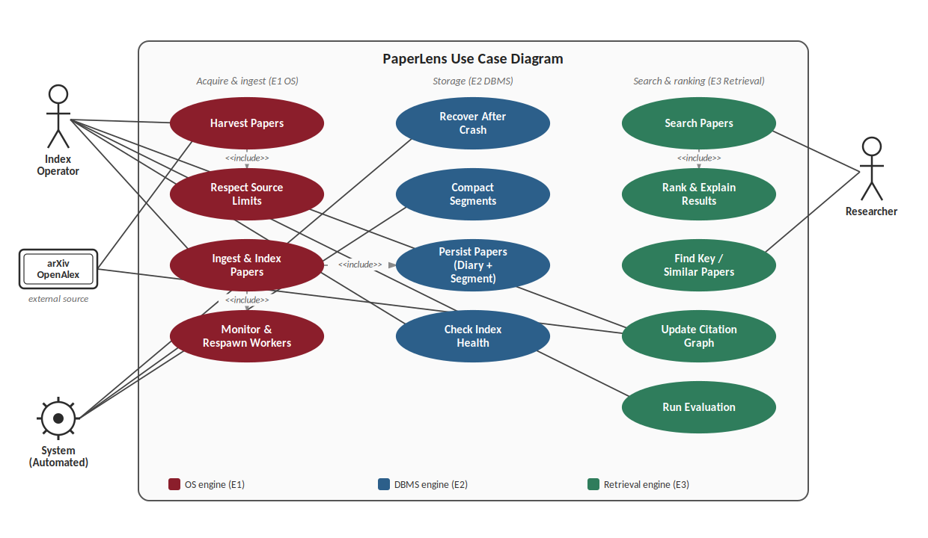
CHECK: Every actor and major use case shown in the diagram must correspond to the use case / user story table.

EVIDENCE 3 OF 7 — ACCEPTANCE CRITERIA SHEET
Stage S1 — Functional Requirements Engineering | General, Theme-Independent

1. Acceptance Criteria per Requirement
For every requirement, state the specific, testable condition(s) that define it as 'done'.
Requirement ID | Acceptance Criteria | Test / Verification Method
FR1 | A 1,000-record run stores 1,000 valid records and resumes after a stop with no duplicates; arXiv requests are at least 3 s apart and a 503 with Retry-After is waited out. | tests/test_harvester.py; tests/test_coord.py; request-log check on a short live run
FR2 | With readers killed at random and the writer killed twice, no paper is lost or duplicated; a paper that always crashes workers is parked; a second writer is refused. | tests/test_pipeline.py; tests/test_index.py
FR3 | After a kill at each of 6 write steps and 12 random SIGKILLs every acknowledged paper is present; reopening removes incomplete segments and replays the diary; a merge does not change query results and a crash during a merge recovers. | tests/test_crash.py; tests/test_index.py; Phase 5 compaction tests (planned)
FR4 | BM25 scores equal a brute-force implementation to 1e-9; compressed vector search recovers at least 95% of the exact top-10 with codes at most 1/8 of float32 size. | tests/test_tokenizer.py; tests/test_index.py; Phase 3 recall-versus-bits experiment (planned)
FR5 | The hybrid list equals the reciprocal-rank fusion of the two lists; filters return only matching papers; PageRank matches a reference library within 1e-6; an ablation reports the citation rerank effect on nDCG@10. | Phase 3 to 5 tests and ablation (planned)
FR6 | For 20 sampled results the matched words, meaning score and citation support are correct; MinHash estimates are within 0.05 of exact overlap; ingest, search, stats and fsck work from a clean checkout following the README. | Manual check plus CLI tests; Phase 4 tests (planned)
FR7 | One command reproduces the table of nDCG@10, Recall@100, latency and size for every setup. | tools/eval_beir.py; metric unit tests in tests/test_index.py
FR8 | The reranker can be switched on and off with an ablation; reranking 100 candidates takes at most 300 ms; “Key papers” lists the highest-PageRank papers of the topic. | Phase 6 ablation (planned)
REMINDER: Acceptance criteria must be specific and testable — vague criteria will not pass Gate 1 review.

